**MUSIC.LY**

*A*

*Mini Project Report*

*Submitted in partial fulfilment of the*

*Requirements for the award of the Degree of*

**BACHELOR OF ENGINEERING**

IN

**INFORMATION TECHNOLOGY**

By

**<YAKSHA KASTURI ><1602-19-737-017>**

**<LIKITH KAGITA><1602-19-737-020>**

**<SATHVIK REDDY><1602-19-737-039>**

**Department of Information Technology**

**Vasavi College of Engineering (Autonomous)**

**(Affiliated to Osmania University)**

**Ibrahimbagh, Hyderabad-31**

**2021**

**Vasavi College of Engineering (Autonomous)**

**(Affiliated to Osmania University)**

**Hyderabad-500 031**

**Department of Information Technology**

**DECLARATION BY THE CANDIDATE**

We, **YAKSHA KASTURI, LIKITH KAGITA, SATHVIK REDDY,** bearing hall ticket number, **1602-19-737-017, 1602-19-737-020, 1602-19-737-039** , hereby declare that the project report entitled **<MUSIC.LY >** Department of Information Technology, Vasavi College of Engineering, Hyderabad, is submitted in partial fulfilment of the requirement for the award of the degree of **Bachelor of Engineering** in **Information Technology**

This is a record of bonafide work carried out by me and the results embodied in this project report have not been submitted to any other university or institute for the award of any other degree or diploma.

**YAKSHA KASTURI( 1602-19-737-017)**

**LIKITH KAGITA(1602-19-737-020)**

**SATHVIK REDDY(1602-19-737-039)**

**Vasavi College of Engineering (Autonomous)**

**(Affiliated to Osmania University)**

**Hyderabad-500031**

**Department of Information Technology**

**BONAFIDE CERTIFICATE**

This is to certify that the project entitled **“MUSIC.LY”** being submitted by, **YAKSHA KASTURI**,

**LIKITH KAGITA, SATHVIK REDDY** bearing **1602-18-737-017, 1602-18-737-020, 1602-18-737**

**-039**, in partial fulfilment of the requirements for the completion of MINI PROJECT of Bachelor

of Engineering in Information Technology is a record of bonafide work carried out by them

under my guidance.

B. LEELAVATHY Dr. K. RAM MOHAN RAO Internal Guide HOD, IT

**ACKNOWLEDGEMENT**

I thank the department of INFORMATION TECHNOLOGY, for introducing the subject “mini project-2” in BE fifth semester that let us learn and explore more features in “Web Development with Machine Learning”.

I would also like to show my appreciation to our honourable principal, Dr S V RAMANA sir, for supporting us and our beloved mini project lecturer, Mrs LEELAVATHI mam, for letting us properly understand the process of doing the mini project using Web Development with Machine Learning and for providing insight and expertise that greatly assisted the project.

My family and friends will always be loved for sticking by me through thick and thin. THANK YOU!

**ABSTRACT**

The number of songs available exceeds the listening capacity of an individual in their lifetime. It is tedious for an individual to sometimes choose from millions of songs and, there is also a good chance of missing out on songs that could have been favorites. Sometimes, you may hear a great song on your car radio or in a restaurant but may not know which song it is.

Music.ly aims to provide the perfect fix for these situations.

At its core, Music.ly is a music player. What sets it apart from all the existing music players is that we intend to bring all the best features of different music players/apps out there to bring you the best mixes of music. It includes features like song streaming, song recognition, providing lyrics for songs and recommending songs based on tone analysis.

**CONTENTS**

1 INTRODUCTION 8

1.1 PURPOSE . . . . . . . . . . . . . . . . . . . . . . . . . . . 8

1.2 DOCUMENT CONVENTIONS . . . . . . . . . . . . . . . . 9

1.3 PRODUCT SCOPE. . . . . . . . . . . . . . . 10

1.4 PROBLEM DEFINITION. . . . . . . . . . . . . . . 10

2 RELATED WORK

3 PROPOSED WORK

3.1 USE CASE. . . . . . . . . . . . . . . . . . . . . . . . . . . 12

3.2 UI PROTOTYPES . . . . . . . . . . . . . . . . . . . . . . . . . . . 12

3.3 ARCHITECTURE AND TECHNOLOGY USED. . . . . . . . . . . . . .12

3.4 DESIGN

3.4.1 SEQUENCE DIAGRAM

3.4.2 USE CASE DIAGRAM

3.5 IMPLEMENTATION

3.5.1 SYSTEM ARCHITECTURE. . . . . . . . . . . . . . . . . . . . . . .14

3.5.2 IMPLEMENTATION AND CODE. . . . . . . . . . . . . . . . . 15

3.6 TESTING. . . . . . . . . . . . . . . . . . . . . . . . . . . . . . . . . . . 16

4 RESULTS 28

5 DISCUSSION AND FUTURE WORK

6 REFERENCES

**CHAPTER-1**

**1.INTRODUCTON**

**1.1 PURPOSE**

Rapid development of mobile devices and internet has made possible for us to access different music resources freely. The number of songs available exceeds the listening capacity of single individual. People sometimes feel difficult to choose from millions of songs. Moreover, music service providers need an efficient way to manage songs and help their costumers to discover music by giving quality recommendation. Thus, there is a strong need of a good recommendation system. Currently, there are many music streaming services, like Pandora, Spotify, etc. which are working on building high-precision commercial music recommendation systems. These companies generate revenue by helping their customers discover relevant music and charging them for the quality of their recommendation service. Thus, there is a strong thriving market for good music recommendation systems. Based on the mode we select the songs and recommend to the user.

Many times, we listen to song on a radio or on a restaurant or any other place, but you may not know which song is, and we start searching for the song we may get, or we may not get. So, we need a system which identifies the song and makes our work simple. By our project we may be able to detect the songs which are unknown to us. Generating lyrics to a song, more than listening to a song we enjoy by singing a song. By generating lyrics, it will be easy for singing also. From younger to older everyone wants to listen to the music, wherever we see in a group of 100 people on an average 10 persons will listen to songs. Designing a music player consists of recommending songs on tone based, song streaming, song recognising, providing lyrics for the songs is main objective or main purpose of our project. It is too different from other music apps or music library.

**1.2 DOCUMENT CONVENTIONS**

Main Heading Font size: 20 (bold fonts)

Sub-headings Font size: 16 (bold fonts)

Sub-headings Content Font size: 14 (normal fonts)

**1.3 PRODUCT SCOPE**

There are many projects out there to provide best music player like Spotify, Ganna our project is different from these Music.ly aims to provide the perfect fix for these situations. At its core, Music.ly is a music player. What sets it apart from all the existing music players is that we intend to bring all the best features of different music players/apps out there to bring you the best mixes of music. It includes features like song streaming, song recognition, providing lyrics for songs and recommending songs based on tone analysis.

**1.4 PROBLEM DEFINATION**

It is a music player with multiple features. We can search song, play song depending on our mood. We can also see lyrics. Sometimes we may miss out our favourite song. To solve all these problems, we bring Music.ly. It has all the best features. You can also have your own playlist. There are different genres available.

**CHAPTER-2**

**RELATED WORK**

We have Spotify to listen music, shazam to recognise song and genius app to know the lyrics. Switching of apps is time taking so we bring Music.ly which can do all these tasks. It has all best features from all other versions. You can perform all these tasks simultaneously. It is a single app performing multiple tasks. The three apps can be connected so that you can get some extra benefits if using them together. We are also improving the quality and padding in the app. One of the easiest ways Music.ly lets its users discover new music. It's also the data behind radio, genres, and several of the features on Home and the Discover pages.

**CHAPTER -3**

**PROPOSED WORK**

**3.1 USE CASE-**

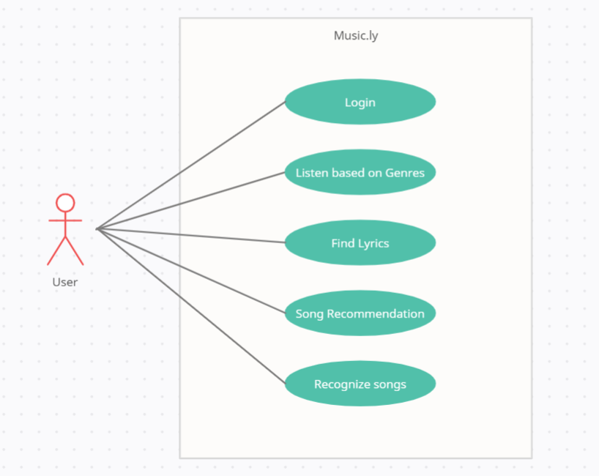

**3.2 UI PROTOTYPES**

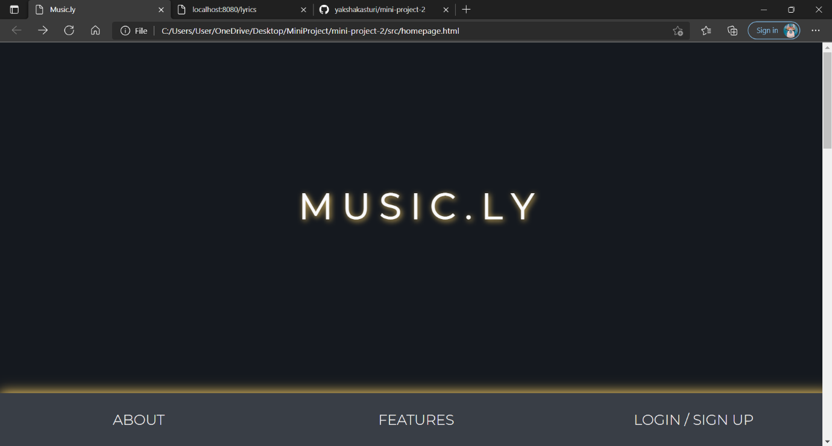

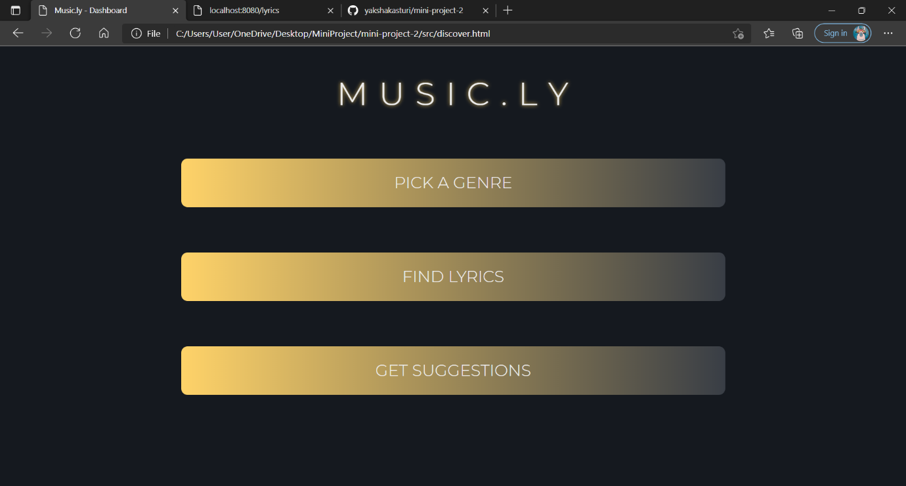

**3.3 ARCHITECTURE AND TECHNOLOGY USED**

**TECHNOLOGY USED**

* HTML
* CSS
* JAVA SCRIPT
* NODE JS
* EXPRESS JS
* PYTHON

**3.4 DESIGN**

**SEQUENCE DIAGRAM**

**USE CASE DIAGRAM**



**3.5 IMPLEMENTATION**

**3.5.1 SYSTEM ARCHITECTURE**

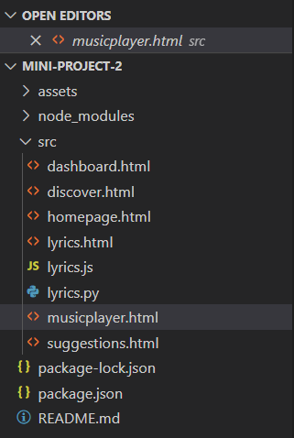

**3.5.2 IMPLEMENTATION AND CODE**

1. Genres

<!DOCTYPE html>

<html lang="en" >

<head>

<meta charset="UTF-8">

<title>Music.ly - Genres</title>

<link rel='stylesheet' href='https://fonts.googleapis.com/css?family=Montserrat:700"rel="stylesheet'>

<link rel="stylesheet" href="../assets/dashboard.css">

</head>

<body>

<!-- partial:index.partial.html -->

<div class="wrapper">

<h1> G E N R E S </h1>

<div class="cols">

<div class="col" ontouchstart="this.classList.toggle('hover');">

<div class="container">

<div class="front" style="background-image: url(https://th.bing.com/th/id/R.326de33d0c82486423149eaf3f992df6?rik=dQlNixaqpQ1pHg&riu=http%3a%2f%2fwww.clashmusic.com%2fsites%2fdefault%2ffiles%2fstyles%2farticle_feature%2fpublic%2ffield%2fimage%2fed-sheeran-divide-album-cover-2017-march-1484221917.jpg%3fitok%3dCYHbIS2V&ehk=SYRB54VVrT7TIsMccNQOTGt9AJt8EKvKVJN4zHHyxtU%3d&risl=&pid=ImgRaw&r=0)">

<div class="inner">

<p>POP</p>

</div>

</div>

<div class="back">

<div class="inner">

<p><a href="https://open.spotify.com/genre/pop-page">Check out playlists</a></p>

</div>

</div>

</div>

</div>

<div class="col" ontouchstart="this.classList.toggle('hover');">

<div class="container">

<div class="front" style="background-image: url(https://th.bing.com/th/id/OIP.s3cfFN-o_WGRWmxQOn-VcgHaHa?pid=ImgDet&rs=1)">

<div class="inner">

<p>ROCK</p>

</div>

</div>

<div class="back">

<div class="inner">

<p><a href="https://open.spotify.com/genre/rock-page">Check out playlists</a></p>

</div>

</div>

</div>

</div>

<div class="col" ontouchstart="this.classList.toggle('hover');">

<div class="container">

<div class="front" style="background-image: url(https://th.bing.com/th/id/OIP.E9as335dhY1MZ907Ny2tLQHaHa?pid=ImgDet&rs=1)">

<div class="inner">

<p>JAZZ</p>

</div>

</div>

<div class="back">

<div class="inner">

<p><a href="https://open.spotify.com/genre/jazz-page">Check out playlists</a></p>

</div>

</div>

</div>

</div>

<div class="col" ontouchstart="this.classList.toggle('hover');">

<div class="container">

<div class="front" style="background-image: url(https://th.bing.com/th/id/OIP.e-u2crfN5WAK0Zugz4159wHaHa?pid=ImgDet&rs=1)">

<div class="inner">

<p>HIP HOP</p>

</div>

</div>

<div class="back">

<div class="inner">

<p><a href="https://open.spotify.com/genre/hiphop-page">Check out playlists</a></p>

</div>

</div>

</div>

</div>

<div class="col" ontouchstart="this.classList.toggle('hover');">

<div class="container">

<div class="front" style="background-image: url(https://i.pinimg.com/originals/6b/56/4b/6b564bd2373d471ed13ab27e398157ac.jpg)">

<div class="inner">

<p>TRAVEL</p>

</div>

</div>

<div class="back">

<div class="inner">

<p><a href="https://open.spotify.com/genre/travel-page">Check out playlists</a></p>

</div>

</div>

</div>

</div>

<div class="col" ontouchstart="this.classList.toggle('hover');">

<div class="container">

<div class="front" style="background-image: url(https://www.music-bazaar.com/album-images/vol15/731/731607/2579899-big/Bollywood-Funk-Experience-cover.jpg)">

<div class="inner">

<p>HINDI</p>

</div>

</div>

<div class="back">

<div class="inner">

<p><a href="https://open.spotify.com/genre/bollywood-page">Check out playlists</a></p>

</div>

</div>

</div>

</div>

<div class="col" ontouchstart="this.classList.toggle('hover');">

<div class="container">

<div class="front" style="background-image: url(https://th.bing.com/th/id/OIP.b-x910DtGqztLP1beWe_KgHaHa?pid=ImgDet&rs=1)">

<div class="inner">

<p>TELUGU</p>

</div>

</div>

<div class="back">

<div class="inner">

<p><a href="https://open.spotify.com/genre/telugu-page">Check out playlists</a></p>

</div>

</div>

</div>

</div>

<div class="col" ontouchstart="this.classList.toggle('hover');">

<div class="container">

<div class="front" style="background-image: url(https://i.pinimg.com/originals/89/8b/cf/898bcfc7acf9e84cf06c2c6f535e06b8.jpg)">

<div class="inner">

<p>ANIME</p>

</div>

</div>

<div class="back">

<div class="inner">

<p><a href="https://open.spotify.com/genre/anime-page">Check out playlists</a></p>

</div>

</div>

</div>

</div>

</div>

</div>

<!-- partial -->

</body>

</html>

1. Dashboard

<!DOCTYPE html>

<html>

<title>Music.ly - Dashboard</title>

<head>

<link rel='stylesheet' href='https://fonts.googleapis.com/css?family=Montserrat:700"rel="stylesheet'>

<link rel="stylesheet" href="../assets/discover.css">

</head>

<body>

<div class="flex-container">

<h1> M U S I C . L Y </h1>

<div class="button1"><a href="dashboard.html">PICK A GENRE</a></div>

<div class="button1"><a href="lyrics.html">FIND LYRICS</a></div>

<div class="button1"><a href="suggestions.html">GET SUGGESTIONS</a></div>

</div>

</body>

</html>

1. Homepage

<!DOCTYPE html>

<html lang="en" >

<head>

<meta charset="UTF-8">

<title>Music.ly</title>

<link rel="stylesheet" href="../assets/homepage.css">

</head>

<body>

<!-- partial:index.partial.html -->

<section id="intro" class="page">

<div id="intro-title">

<h1><b>&nbsp;&nbsp;&nbsp;&nbsp;M U S I C . L Y&nbsp;&nbsp;&nbsp;&nbsp;</b></h1>

</div>

<!-- <div id="intro-description">

with sticky nav on sliding

</div> -->

</section>

<nav>

<!-- <a class="menu-btn">

<svg t="1583388234559" class="icon" viewBox="0 0 1024 1024" version="1.1" xmlns="http://www.w3.org/2000/svg" p-id="2279" width="16" height="16"><path d="M128 213.34016l768 0q17.67424 0 30.16704 12.4928t12.4928 30.16704-12.4928 30.16704-30.16704 12.4928l-768 0q-17.67424 0-30.16704-12.4928t-12.4928-30.16704 12.4928-30.16704 30.16704-12.4928zM128 725.34016l768 0q17.67424 0 30.16704 12.4928t12.4928 30.16704-12.4928 30.16704-30.16704 12.4928l-768 0q-17.67424 0-30.16704-12.4928t-12.4928-30.16704 12.4928-30.16704 30.16704-12.4928zM128 469.34016l768 0q17.67424 0 30.16704 12.4928t12.4928 30.16704-12.4928 30.16704-30.16704 12.4928l-768 0q-17.67424 0-30.16704-12.4928t-12.4928-30.16704 12.4928-30.16704 30.16704-12.4928z" p-id="2280" fill="#40403F"></path></svg>

</a> -->

<!-- <a class="tab" data-text="PAGE THREE" href="#three">PAGE THREE</a>

<a class="tab" data-text="PAGE FOUR" href="#four">PAGE FOUR</a> -->

<a class="tab placeholder"></a>

<a class="tab" data-text="ABOUT" href="#one">ABOUT</a>

<a class="tab" data-text="FEATURES" href="#two">FEATURES</a>

<a class="tab" data-text="LOGIN / SIGN UP" href="#login">LOGIN / SIGN UP</a>

</nav>

<a name="one"></a>

<section class="page content-page">

<div>

<b class="heading">ABOUT&nbsp;OUR&nbsp;PROJECT</b>

<p>

The number of songs available exceeds the listening capacity of an individual in their lifetime.

It is tedious for an individual to sometimes choose from millions of songs and, there is also a good chance of missing out on songs that could have been favorites.

Sometimes, you may hear a great song on your car radio or in a restaurant but may not know which song it is.<br>

Music.ly aims to provide the perfect fix for these situations.<br>

</p>

</div>

</section>

<a name="two" id="content"></a>

<section name="two" class="page content-page">

<div >

<b class="heading">FEATURES</b>

<p>

At its core, Music.ly is a music player. <br>

What sets it apart from all the existing music players is that we intend to bring all the best features of different music players/apps out there to bring you the best mixes of music. <br>

It includes features like <br>

<ul>

<li> Song Streaming </li>

<li> Song Recognition </li>

<li> Providing lyrics for songs </li>

<li> Recommending songs based on Tone Analysis </li>

</ul>

</p>

</div>

</section>

<!-- <a name="three"></a>

<section name="three" class="page content-page">

<div>

PAGE THREE

</div>

</section>

<a name="four"></a>

<section name="four" class="page content-page">

<div>

PAGE FOUR

</div>

</section> -->

<a name="login" id="content"></a>

<section name="login" class="page content-page">

<div class="main">

<p class="sign" align="center">SIGN IN</p>

<form class="form1">

<input class="un" type="text" align="center" placeholder="Username">

<input class="pass" type="password" align="center" placeholder="Password">

<a class="submit" align="center" href="discover.html">Sign in</a>

<p class="forgot" align="center"><a href="#"> Forgot Password?</p>

</div>

</section>

<!-- partial -->

<script src="../assets/homepage.js"></script>

</body>

</html>

1. Get Lyrics

<!DOCTYPE html>

<html>

<head>

<link rel="stylesheet" href="../assets/lyrics.css">

<script src="lyrics.js"></script>

<script src="https://genius.codes"></script>

<title>Music.ly - Find Lyrics</title>

</head>

<body>

<h1> L Y R I C S </h1>

<form ction="http://localhost:8888/path" method="GET">

<input class="searchbar" type="text" name="searchlyrics" placeholder="Search by song name..">

</form>

<p>

The lyrics go here.

</p>

<div id="get-lyrics"></div>

</body>

</html>

1. Suggestions

<!DOCTYPE html>

<html>

<head>

<link rel="stylesheet" href="../assets/lyrics.css">

<title>Music.ly - Get Suggestions</title>

</head>

<body>

<h1> S U G G E S T I O N S </h1>

<p>

Work in progress....

</p>

</body>

</html>

**GIT HUB LINK**

<https://github.com/yakshakasturi/mini-project-2>

**3.6 TESTING**

**CHAPTER -4**

**RESULT**

**CHAPTER -5**

**DISCUSSION AND FUTURE WORK**

We have a lot of plans that we would like to add a lot of elements to our project. We would like to add more file types and also improve our security.

I would like to make the code simpler and easier to understand.

**ADDITIONAL LEARNING**

We learned how to manage time. Though we had lot of quizzes and assignments we somehow managed to pull up. This project helped us to gain interest in coding. From many topics we choose music.ly and we went through a lot but as a team we faced them. We had an amazing experience working together.

Teamwork made understanding of our project a lot easier and helped us to be more creative in various steps of its development. We also had to revise a lot of concepts regarding web development with machine learning, which made our basics even stronger and also helping us to be even more confident.

**CHAPTER -6**

REFERENCES

* <https://docs.python.org/3/>
* <https://developer.mozilla.org/en-US/>
* <https://docs.python.org/3/library/tk.html>
* <https://rapidapi.com/hub>